The Animals Save the Planet: Before the Film
- Explain or translate the terms:

- REUSE

- RECYCLE

- TRASH

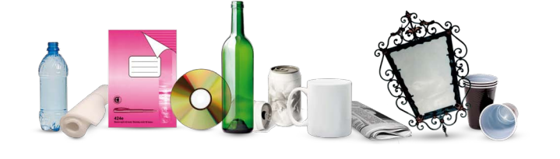
- What things can you see in the picture? Which of them can we recycle? Circle or mark.

- What can you put into these dumpsters (kontejnery)? Write one general term (glass, plastic, paper) and at least 5 specific things for each.

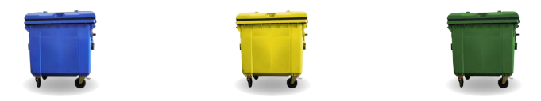
BLUE: YELLOW: GREEN:
Specific things: Specific things: Specific things:

Do you know any other colours of the dumpsters? What can you put into them?

